Jenkins

* Jenkins is CI/CD (continues Integration / continues delivery or deployment )tools.
* It is free and open source for all
* It is written in java.

## CI(continues Integration ):

Dev => Application Test => Integration test

## CD(Continues Delivery ):

Dev => Application test => Integration test => Acceptance Test

## Continues Deployment:

Deb => Application test => Integration Test => Acceptance Test => Production

### how to load the jenkins in your system

* Download the jenkins war file
* Open that file location in cmd
* Then type the command : “ java -jar Jenkins.war “ then press enter it start in default port 8080.
* If you want change the port :” java -jar Jenkins.war --httpPort=9191” hit enter then jenkin will start loading .
* If you have the latest version of jdk then you can use this :“ java -jar jenkins.war --enable-future-java” command .
* Then copy the admin password from the “C:\ProgramData\Jenkins\.jenkins\secrets\initialadminpassword” copy that password.
* Then go to <http://localhost:9191> or <http://localhost:8080> these location in browser and set up the Jenkins
* Here your to paste the initadminpassword which you copy in previous step and hit enter.

# How to change home directory :>

* Check your Jenkins home > Manage Jenkins > Config system
* Create a new folder
* Copy the data from old directory to new folder.
* Create/update environment variable Jenkins_home.
* Restart Jenkins.

# How to setup git in Jenkins

* Go manage Jenkins > manage plugin
* Check if git is already installed or not in installed plugins tab.
* Else go to available plugins tab and search for git.
* Install git.
* Check git option is present in job Configuration.

# How to create a job on Jenkins:>

* Click on create a job or new item in top left corner.

# How do you connect with the git remote repository in jenkins:

* Get the url of the remote Repository
* Add the git credential to the Jenkins.
* In the Jobs configuration go to SCM and provide git repo url in git sections.
* Add the credential.
* Run job and check the repository is cloned.

# How to use command line in Jenkins CLI:

* Start Jenkins.
* Goto manage Jenkins – configure global security – enable security.
* Goto – <http://localhost:8080/>
* Download Jenkins-cli.jar place at any location.
* Test the Jenkins the Jenkins command line is working.
* <http://localhost:8080/cli/> in this address you can find all the Jenkins cli command.

# How to create users + manage + Assign role:

* How to create user:

1. Click on manage Jenkins
2. Manage users
3. Click on create user
4. Fill the form
5. Confirm and click on create user is blue box.

* How to configure user:

1. Click on configure user.

* How to create new role:
  1. Go to dashboard.
  2. Manage Jenkins
  3. Plugins
  4. Go to available section and search for role.
  5. You will find a role-based-authorization-strategy
  6. Select this and click on install without restart.
* How to assign users to role:

1. Manage Jenkins.
2. Security.
3. Configure global security.
4. Authorization
5. Select role-based Strategy.
6. Apply and save.
7. Manage Jenkins.
8. **Manage and assign role**.
9. First click on manage role.
10. Then add role like employee or anything.
11. And give permission to employee whatever you want, but for learning purpose give read permission only.
12. Go to item role
13. Then add some role like “Tester” and give a pattern like “Test.*” then click on add.
14. Then add one more role like “Developer” and give this a pattern like “Dev.*” then click on add.
15. And give them all the permission.
16. Then at the end you apply and save this.
17. **Then after the go to assign role**.
18. Here in global role add your users and then tell them what they are like admin or employee.
19. Then give them item specific role.
20. Add users here also.
21. And make them they developer or test.
22. Then at the end click on apply and save.

* How to control user access on project:

1. Then create your job like demoJob or debJob.
2. As an admin you can view all the thing but if we switch user.
3. Form example we create user like user1 or user2.
4. They only can access only what the admin want him to do by giving them permission.

# How to chain the Jobs in Jenkins:

For this you have to create as many job you want to create.

1. Create a job
2. Go to config.
3. Then go to build step.
4. And add execute window batch command.
5. And type any message like: echo “ I am in this”.
6. Do this for all the job you created.
7. Now click on any job.
8. Then go the post-build Actions.
9. Click on build-other project.
10. And give the name of the Job you perform after that.
11. And select trigger if the build is statble.
12. Then apply and save.
13. Now you want to perform all the job together then click on the 1st job in the queue and that will perform all the stable build in queue.

**If you see you actually create a pipeline. To see this got manage Jenkins.**

* Then go manage Jenkins > plugin > available plugin > search build pipeline > select build pipeline > install without restart.

*note* **this is not safe because there is some vulnerability issue in this I am using the dummy project for learning purpose you can only use this In actual project never use this**.

* Now in your Jenkins dashboard you can see a “+” button in the above you jobs right site of “all” you have click on that button.
* Now you see the build pipeline view click on that > give a name like ‘buildPipeline’ > then click on create.
* After that first your have to select the Select Initial Job in, your chain.
* Then select the no. of displayed builds means how many build you want to display.
* The it will look like this:

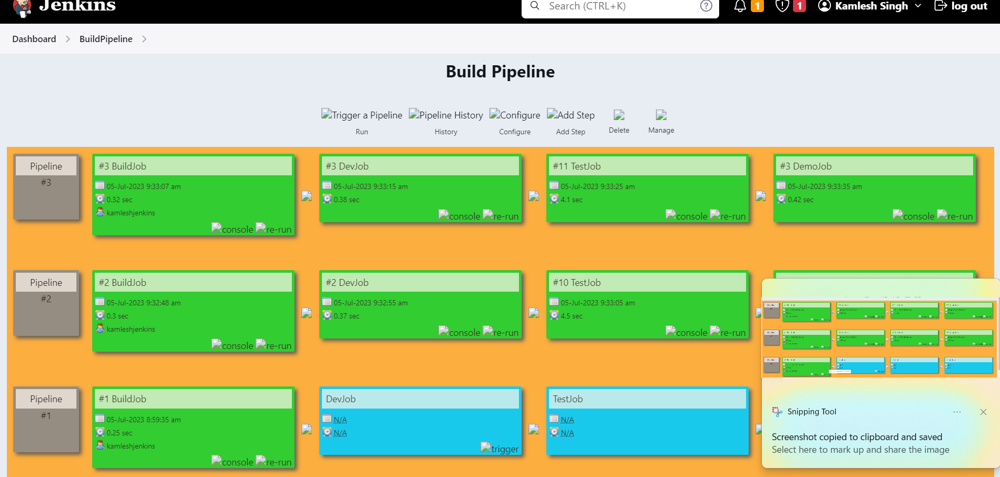

* **Now you can run your job from here too.**